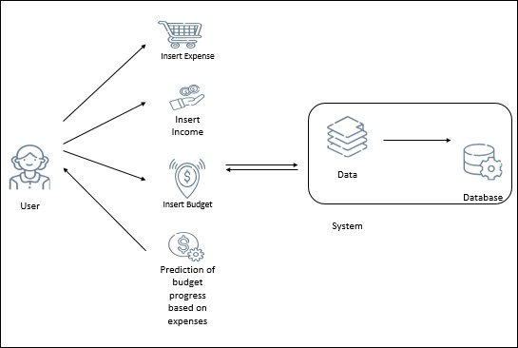Data Flow Diagrams: DFD (level 0):

# Project Design Phase-II

**Data Flow Diagram & User Stories**

|  |  |
| --- | --- |
| Date | 15 October 2022 |
| Team ID | PNT2022TMID39972 |
| Project Name | Personnel Expence Tracker application |
| Maximum Marks | 4 Marks |

DFD (level 1):

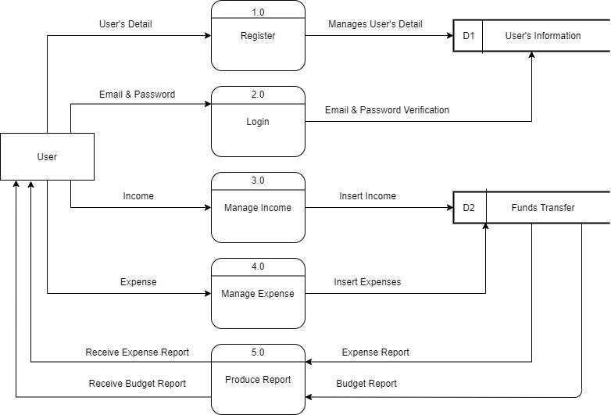

DFD (Level 2):

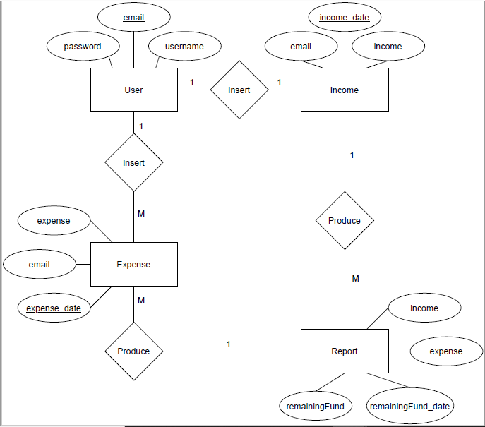

User Stories

Use the below template to list all the user stories for the product.

|  |  |  |  |  |  |  |
| --- | --- | --- | --- | --- | --- | --- |
| **User Type** | **Functional Requirement (Epic)** | **User Story Number** | **User Story / Task** | **Acceptance criteria** | **Priority** | **Release** |
| Customer (Mobile user) | Registration | USN-1 | As a user, I can register for the application by entering my email, password, and confirming my password. | I can access my account / dashboard | High | Sprint-1 |
|  |  | USN-2 | As a user, I will receive confirmation email once I have registered for the application | I can receive confirmation email & click confirm | High | Sprint-1 |
|  |  | USN-3 | As a user, I can register for the application | I can use my gmail | Medium | Sprint-2 |
|  | through Gmail | credentials instead of |  |  |
|  |  | manually entering my |  |  |
|  |  | details |  |  |
|  | Login | USN-4 | As a user, I can log into the application by entering email & password | I can retrieve my information | High | Sprint-1 |
|  | Dashboard | USN-5 | As a user, I can continue my old progress | I can continue where I left | Medium | Sprint-1 |
| Customer (Laptop user) | Registration | USN-1 | I can register for the application using browser by entering the email, password, name and personal information and conforming my  password | I can access my profile | High | Sprint-1 |
|  |  | USN-2 | As a user, I will receive a confirmation and greeting mail from the web application | I can receive the confirmation and greeting mail | High | Sprint-1 |
|  |  | USN-3 | As a user, I can register for the application | I can use my gmail | Medium | Sprint-1 |
|  | through Gmail | credentials instead of |  |  |
|  |  | manually entering my |  |  |
|  |  | details |  |  |
|  | login | USN-4 | As a user, I can log into the application by entering email & password | I can retrieve my profile | High | Sprint-1 |
|  | Dashboard | USN-5 | As a user, I can view my personalized dashboard | I can continue where I left | medium | Sprint-2 |
|  | Chatbot | USN-6 | As a user, I expect a bot to assist me | I can interact with the bot | High |  |
| Administration | Login | USN-1 | As a admin, login on admin page | I can access admin menu | High | Sprint-2 |
|  |  | USN-2 | As a admin, access the admin menu using admin credentials | I can log in using admin credentials | High | Sprint-2 |

|  |  |  |  |  |  |  |
| --- | --- | --- | --- | --- | --- | --- |
| **User Type** | **Functional Requirement**  **(Epic)** | **User Story Number** | **User Story / Task** | **Acceptance criteria** | **Priority** | **Release** |
|  | Dashboard | USN-3 | As a admin, manage the application through admin panel | I can access admin panel | HIgh | Sprint-3 |
|  |  | USN-4 | As a admin, add and remove available products from data base | I can access database | High | Sprint-3 |